**Zenith Chronicle**

**Documentation**

**Presented By**

Sirapoom Leesuravanich 6330539421

Panithi Khamwangyang 6330301321

**2110215 Programming Methodology**

**Semester 1 Year 2021**

**Chulalongkorn University**

**Zenith Chronicle – RPG hack&slash 2D-platformer Game**

**Introduction**

Zenith Chronicle is a game where player take the role of a treasure hunter to find the lost artifacts that disappeared during the old war of the old gods. With various types of artifacts and power ups found on the way, players have to make their ways to the end of the journey and collect all of the artifacts.

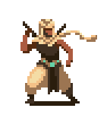**Main Character**

This is a character and only character   
that player can control. He always spawn  
with 100 HP.

**Powerup**

Powerups are items found on the ground. Each one has  
their own effects and is stackable if one has multiples.  
There are 4 types of powerup.



Red potion : instantly recover some health points for player.

Apple : give player a small attack buff.

Blue fish : give player a small movement buff.

Red flower : give player a small jump height buff.

**Artifact**

By slaying enemies, they will occasionally drop artifacts which will have its own effects while holding and is stackable. There are 6 types of artifacts.

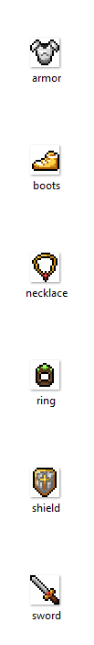

Armor : give boosts to player’s max health points.

Sword : give boosts to player’s attack damage.

Boots : give boosts to player’s movement speed.

Ring : give boosts to player’s jump height.

Necklace : give boosts to player’s dash speed.

Shield : give boosts to player’s health point regeneration.

**Enemy**

There are two types of enemies in this game, which is boss and monster. Boss will be the only enemy in boss stage.   
 The enemies’ strength base are base on difficulty and is stronger in every stage.

**Monster**

Monster is a type of enemy and only contain 2 types : Skeleton and Mushroom. They gain HP, attack points and movement speed as the game progress.

**Boss**

Boss is a type of enemy and this game has only one boss. He gains HP, attack points and attack speed as the game progress.

**Game Control**

(How to play picture)

**Gameplay & Scene**

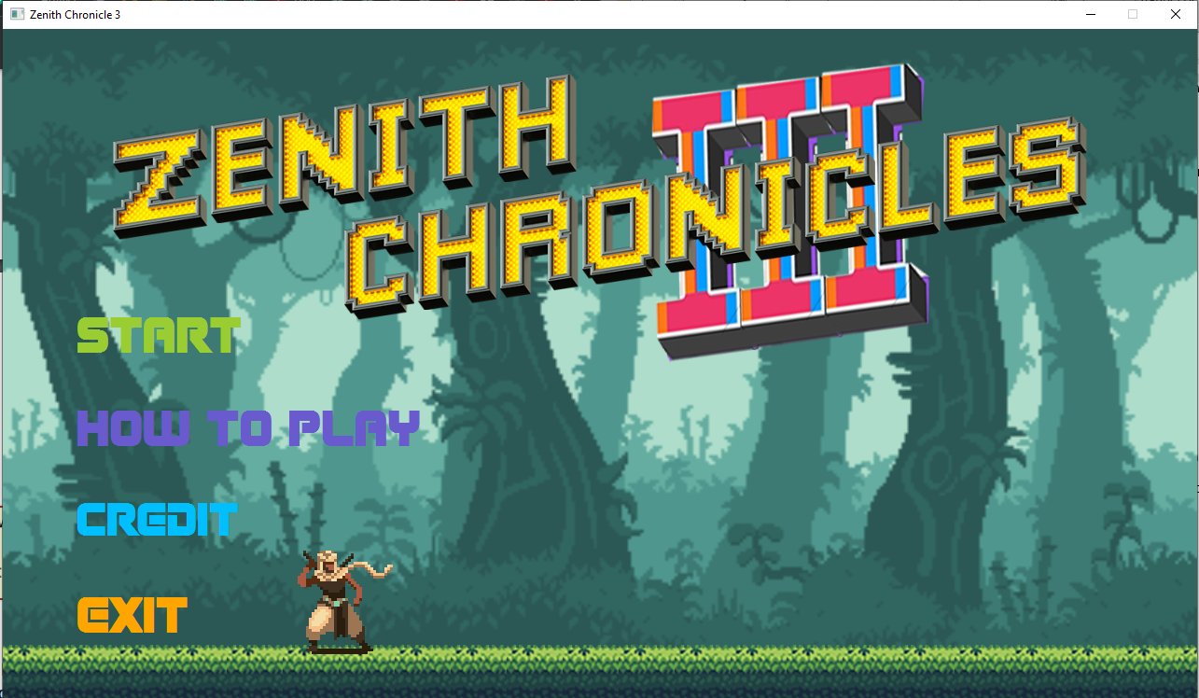**Main Menu**

Figure 7 : Main Menu

When player open the game, they will see the Main Menu. This scene has 4 buttons which is “Start”, which will show the select game difficulty scene, “How to play”, to show how to play the game, “Credit”, to show credit, and “Quit”, which will end the game.

**How-to-play Scene**

Figure 8 : How-to-play

Only one option player can do is to go back to the Main Menu by press the “Back” button or press esc.

**Credit Scene**

Figure 9 : Credit Scene

Same as the How-to-play scene, player have only one option to go back to Main Menu by press the “Back” button or press esc.

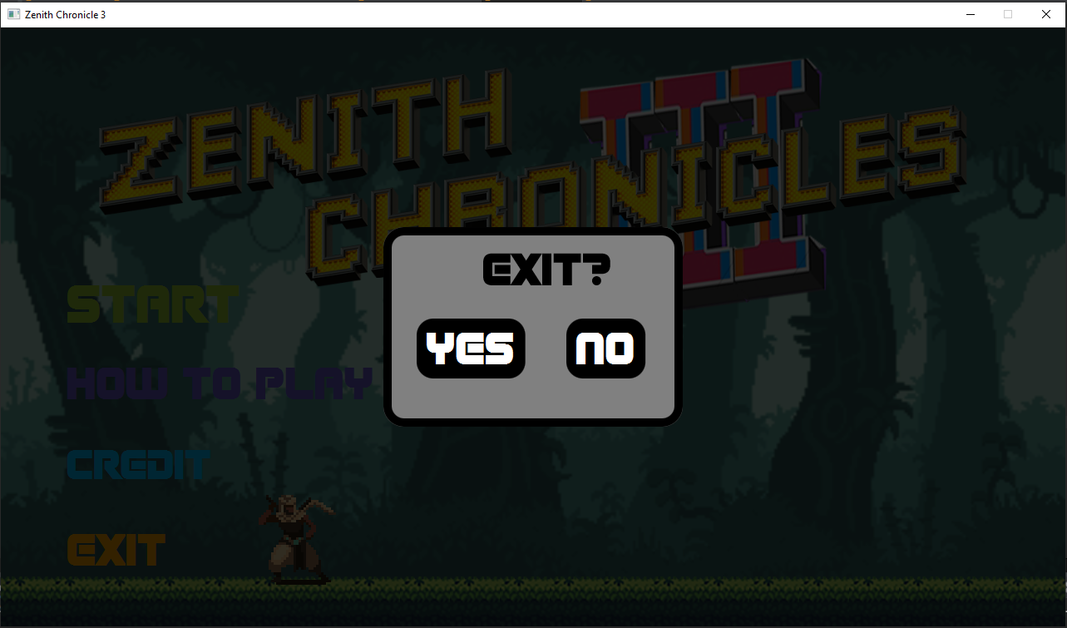**Exit scene**

Figure 10 : Exit scene

Player have two options to end the game or to go back to the main menu.

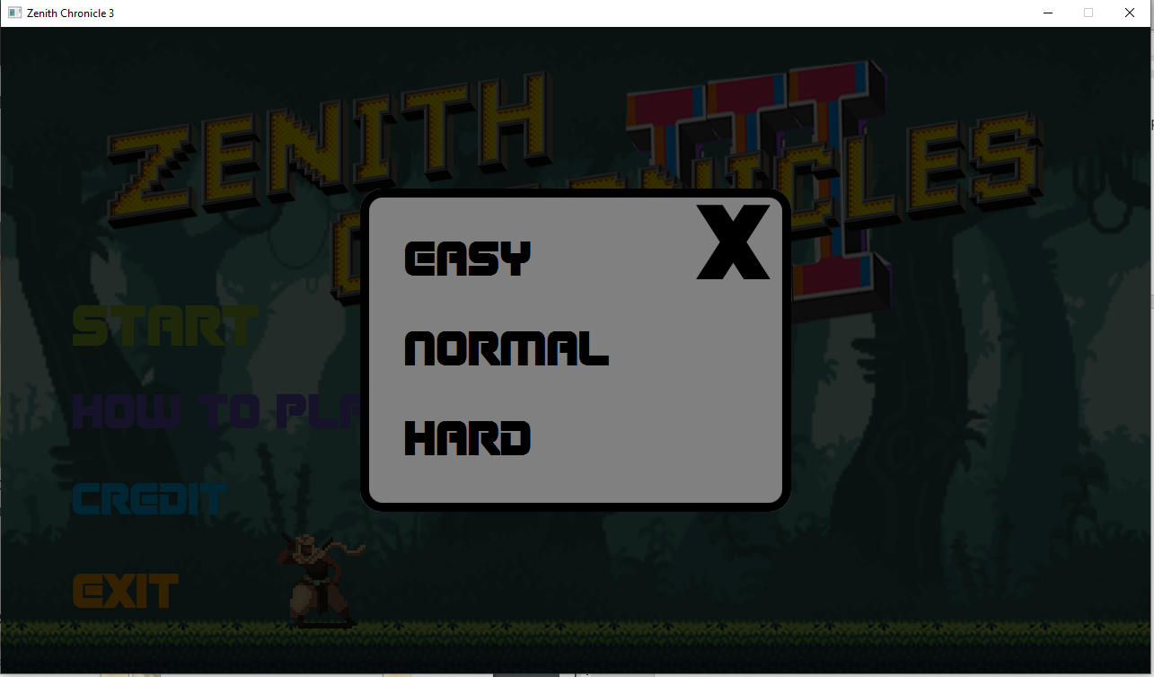**Select difficulty scene**

Figure 11 : Select difficulty scene

Player have four options : Choose one of the three the difficulty and go to Playing Scene or they can choose to go back to main menu.

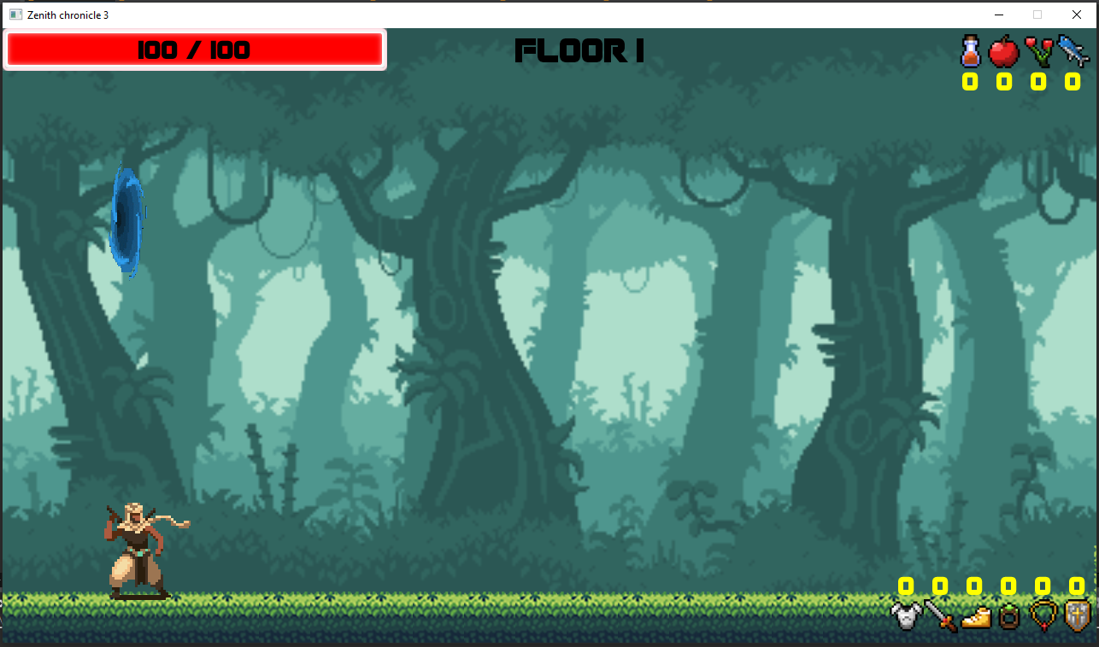**Playing scene**

Figure 12 : Playing scene

This is game scene where the game will be playing. Player will always spawn on the left side of the screen. Top-left corner show health bar of the player. Top-right corner show the temporary buffs that player currently have. And button-right corner will show the artifact that player had collect throughout the game.

When the player make their way to the right-end of the scene, They will find a new portal to the next floor.

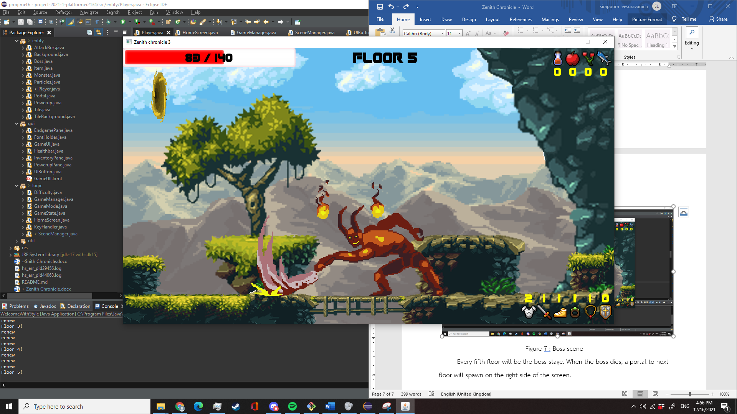**Boss scene**

Figure 13 : Boss scene

Every fifth floor will be the boss stage. When the boss dies, a portal to next floor will spawn on the right side of the screen.

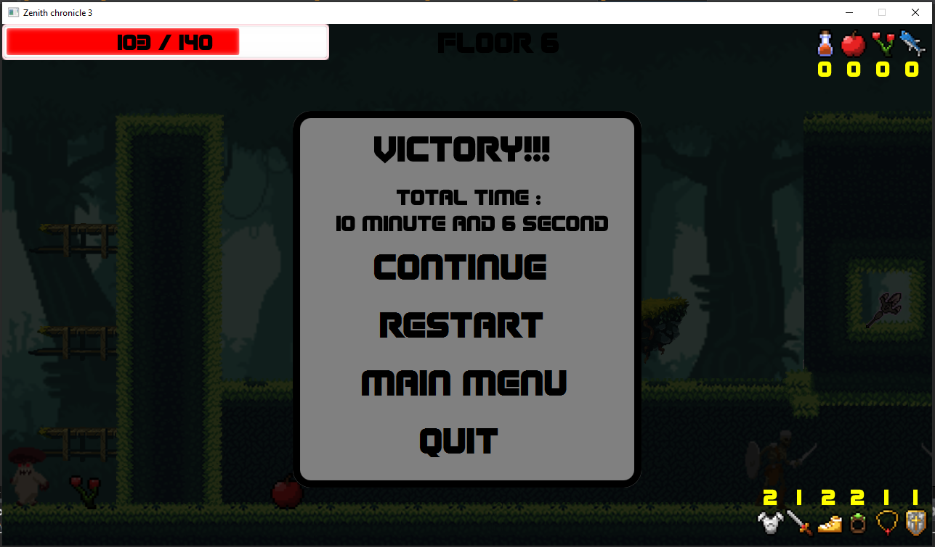**Victory scene**

Figure 13 : Victory scene

When the player had collected all types of artifacts, they win the game. They have four options, Continue : Continue playing until dies, Restart : Start over from the beginning, Main menu : Go back to the main menu, Quit : Quit the game.

**Death scene**

Figure 14 : Death scene

After win the game, If player chose to continue fighting and die, they will see this scene showing how long they have managed to survived throughout the game. The player will have 3 options as same as Victory scene but without Continue button.

**Lose scene**

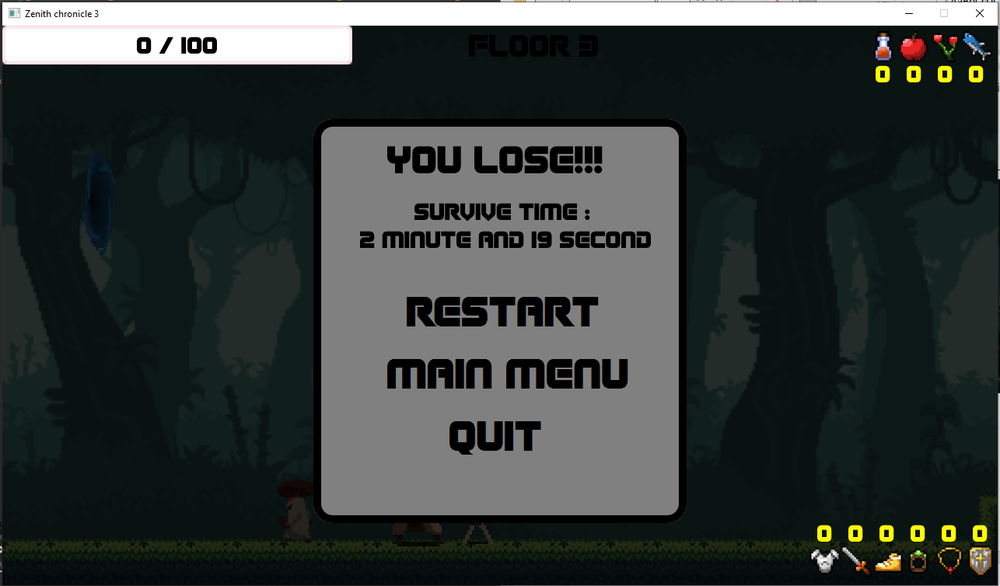

Figure 15 : Lose scene

If the player die without collecting all types of the artifacts. They will see this scene and will have the same options as in Death scene.

(uml here)

..

.

.

.

.

.

(doc here)

1. Package component

1.1 class Sprite

Contains image data for an in-game sprite.

1.1.1 Constructors

|  |  |
| --- | --- |
| + Sprite(string filepath) | Initialize these fields:  Set this.filepath as the argument filepath  Set image using new Image(ClassLoader.getSystemResource(  this.filepath).toString()) |

1.1.2 Fields

|  |  |
| --- | --- |
| -Image image | Image object contains sprite’s image |
| -String filepath | The image’s file path |
|  |  |

1.1.3 Methods

|  |  |
| --- | --- |
| +void loadImage() | Load image from filepath to image |
| Getters for each fields |  |

2 Package entity.base

2.1 abstract class Entity  
 A base structure for all entities that will exist in the game.

2.1.1 Fields

|  |  |
| --- | --- |
| -double x | Coordinate x of the entity |
| -double y | Coordinate x of the entity |
| -int w | Entity’s width |
| -int h | Entity’s height |
| #prevx | Coordinate x in the last frame |
| #prevy | Coordinate y in the last frame |

2.1.2 Methods

|  |  |
| --- | --- |
| *+void update()* | Update entity states and attributes each time is called. |
| *+Sprite getImage()* | Returns Sprite object member of entity.  Note that an entity can have multiple sprites. |
| + draw(GraphicsContext gc, Image img, double x, double y, int w, int h) | Use graphics context to draw img on screen at coordinates (x, y) with w width and h height |
| + draw(GraphicsContext gc, boolean f) | * Call the original draw method with different arguments that depends on f argument * Will draw flipped image if f is true |
| +boolean collideWith(Entity other) | Check if with this entity and other collides |
| +void increaseX(double x) | Increase x value. Note that if x is negative then this will decrease x value. |
| +void increaseY(double y) | Increase y value |
| Getters and Setters for each field |  |

2.2 abstract class FallObject extends Entity

2.2.1 Constructors

|  |  |
| --- | --- |
| +void FallObject() | Calls super’s constructor |

1.2.1 Fields

|  |  |
| --- | --- |
|  |  |
|  |  |
|  |  |
|  |  |

1.2.2 Methods

|  |  |
| --- | --- |
|  |  |
|  |  |
|  |  |
|  |  |

1.2 ...  
1.2.1 Fields

|  |  |
| --- | --- |
|  |  |
|  |  |
|  |  |
|  |  |

1.2.2 Methods

|  |  |
| --- | --- |
|  |  |
|  |  |
|  |  |
|  |  |

1.2 ...  
1.2.1 Fields

|  |  |
| --- | --- |
|  |  |
|  |  |
|  |  |
|  |  |

1.2.2 Methods

|  |  |
| --- | --- |
|  |  |
|  |  |
|  |  |
|  |  |

1.2 ...  
1.2.1 Fields

|  |  |
| --- | --- |
|  |  |
|  |  |
|  |  |
|  |  |

1.2.2 Methods

|  |  |
| --- | --- |
|  |  |
|  |  |
|  |  |
|  |  |

1.2 ...  
1.2.1 Fields

|  |  |
| --- | --- |
|  |  |
|  |  |
|  |  |
|  |  |

1.2.2 Methods

|  |  |
| --- | --- |
|  |  |
|  |  |
|  |  |
|  |  |

1.2 ...  
1.2.1 Fields

|  |  |
| --- | --- |
|  |  |
|  |  |
|  |  |
|  |  |

1.2.2 Methods

|  |  |
| --- | --- |
|  |  |
|  |  |
|  |  |
|  |  |

1.2 ...  
1.2.1 Fields

|  |  |
| --- | --- |
|  |  |
|  |  |
|  |  |
|  |  |

1.2.2 Methods

|  |  |
| --- | --- |
|  |  |
|  |  |
|  |  |
|  |  |

1.2 ...  
1.2.1 Fields

|  |  |
| --- | --- |
|  |  |
|  |  |
|  |  |
|  |  |

1.2.2 Methods

|  |  |
| --- | --- |
|  |  |
|  |  |
|  |  |
|  |  |

1.2 ...  
1.2.1 Fields

|  |  |
| --- | --- |
|  |  |
|  |  |
|  |  |
|  |  |

1.2.2 Methods

|  |  |
| --- | --- |
|  |  |
|  |  |
|  |  |
|  |  |

1.2 ...  
1.2.1 Fields

|  |  |
| --- | --- |
|  |  |
|  |  |
|  |  |
|  |  |

1.2.2 Methods

|  |  |
| --- | --- |
|  |  |
|  |  |
|  |  |
|  |  |

1.2 ...  
1.2.1 Fields

|  |  |
| --- | --- |
|  |  |
|  |  |
|  |  |
|  |  |

1.2.2 Methods

|  |  |
| --- | --- |
|  |  |
|  |  |
|  |  |
|  |  |

1.2 ...  
1.2.1 Fields

|  |  |
| --- | --- |
|  |  |
|  |  |
|  |  |
|  |  |

1.2.2 Methods

|  |  |
| --- | --- |
|  |  |
|  |  |
|  |  |
|  |  |

1.2 ...  
1.2.1 Fields

|  |  |
| --- | --- |
|  |  |
|  |  |
|  |  |
|  |  |

1.2.2 Methods

|  |  |
| --- | --- |
|  |  |
|  |  |
|  |  |
|  |  |

1.2 ...  
1.2.1 Fields

|  |  |
| --- | --- |
|  |  |
|  |  |
|  |  |
|  |  |

1.2.2 Methods

|  |  |
| --- | --- |
|  |  |
|  |  |
|  |  |
|  |  |

1.2 ...  
1.2.1 Fields

|  |  |
| --- | --- |
|  |  |
|  |  |
|  |  |
|  |  |

1.2.2 Methods

|  |  |
| --- | --- |
|  |  |
|  |  |
|  |  |
|  |  |